

Report on 13th European Signal Processing Conference
EUSIPCO2005

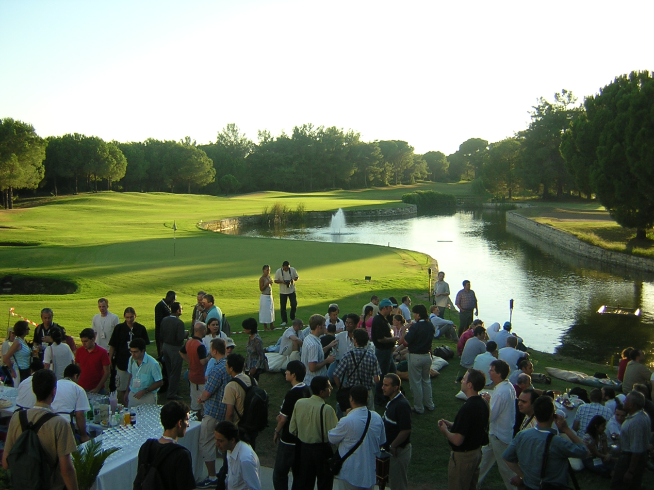

The 13th European Conference on Signal Processing took place in Antalya Turkey from September 4 to 8. EURASIP sponsored EUSIPCO conferences had started in 1980 at Lausanne and has since then zigzagged throughout European cities such as Barcelona, Erlangen, Grenoble, Tampere, Toulouse, Amsterdam, Trieste, Rhodes, Brussels, Edinburgh and Vienna. Antalya, a flourishing Mediterranean city on the southern coast of Turkey, provided the right setting for the conference with its beautiful panoramas, modern infrastructure and social activities.

The technical program consisted of 656 papers, selected after peer review process that engaged 485 reviewers and their 1858 review reports. The acceptance ratio was 70.4%. The program included 153 special session papers that were also subjected to peer review. The conferences consisted overall of 92 sessions spread over full four days and four plenary talks. It is worthwhile to note that five European Framework 6 project activities took place in the conference either in the form of special sessions or project meeting groups. The accepted papers came from 50 different countries, with France, UK, USA, Turkey, Italy, Germany and Spain leading. The geographical distribution of the paper resulted in 64% European contributions, 21% North and South American contribution, and 15% from Asia.

The plenary speeches were given by Khalid Sayyod, University of Nebraska on “Data compression and bioinformatics searching for structure in all kinds of places”, by Eric Badique, European Commission, “EC programs in signal processing: FP6 and beyond”, by Haldun Özaktaş, Bilkent University, on “Optical information processing“ and finally by Jens-Reiner Ohm on “Advances in video compression”. The first day of the conference included five tutorial courses, two of them with open public access. The open tutorials were on “Architectures and tools for digital rights management of multimedia content“and on “Mobile multimedia services“. One of the culminating events of the conference was the student paper competition. The first prize was shared between the paper entitled “Nonlinear common vectors for pattern classification” authored by Hakan Cevikalp, Marian Neamtu and the paper “Support vector machine (SVM) classification through geometry” by Michael Mavroforakis, Sergios Theodoridis. The second place went to Simon Shelley and Damian Murphy with their paper “Diffusion modelling at the boundary of a digital waveguide mesh”. Finally the third prize was given to Ender Konukoglu, Burak Acar, David S. Paik, Christopher F. Beaulieu, Sandy Napel with their paper entitled “Heat diffusion based detection of colonic polyps in CT colonography”.

